**Reviewer #1 Comments**

The authors use an approach from a different field to investigate interdependencies between a water and electrical network. They use this approach to account for the uncertainties associated with the functionality/behavior. They also apply a well-known social science index, SoVI, to try to account for non physical-infrastructure factors in the assessment. They provide definitions for resilience in terms of functionality.   
  
The study is interesting in that it does apply a unique approach. A few comments for the authors consideration which should be addressed:   
  
**1. The approach is new for this application, but neither the approach, nor the resilience aspects are actually new. The authors need to better articulate exactly what their contributions will be early on in the paper.**

**Response:** Thank you for your comment. We listed the contributions in the first section of our manuscript and have added the following text after the first bullet point to highlight the contribution of including SoVI in the estimation of interdependent links:

To the best of our knowledge, this study is the first to incorporate SoVI to estimate the interdependency links.

2**. The Shelby County model has been used so much I find it actually detracts from the originality of the paper. If the authors have the ability to use another network, they definitely should for this, or at the last moving forward.**

**Response:** We agree that the ICIs of Shelby County has been used in a lot of studies. In our study, those ICIs were employed to illustrate the method because we currently don’t have other appropriate data about ICIs to work with. We would very much like to use other freely accessible data about ICIs in the future.  
  
3. **Given (2) above, have the authors validated their results with the work of others? There is work by Gardoni et al on Shelby County and water-electrical networks that can be compared. These references should also be included.**

**Response:** Thank you for the comment. We haven’t validated our results with other studies because although there are many studies used ICIs of Shelby County, few of them investigated ICIs. We found one work of Gardoni et al (Roberto Guidotti et al., 2016) that assessed the resilience of water networks and power network in a probabilistic manner, but in this work the interdependency between networks are deterministic. Related work of Gardoni and other scholars have been included in the latest version of our manuscript to make our literature review more comprehensive.  
  
4. **Figure 4 and the way the disruptive event slowly degrades the functionality of the network is not exactly correct. The authors should better define the vertical axis in the plot, if it includes social components?**

**Response:** Fig.4 is a schematic in which the time scale does not represent the reality. For example, *td* - *te* is usually much smaller than *tf* - *ts*. so the functionality deterioration can occur rapidly (*td* - *te* is small). We have added the following note in the caption to articulate this point:

Note that *td*−*te* is typically much smaller than *tf*−*ts*as the system performance can degrade very rapidly while the recovery occurs much more slowly.

5. **The conclusions seek to conclude about the network and how to restore systems, i.e. dynamic restoration. This is not new at all - the authors need to explain exactly what is new and why the block chain approach uncovered something that was previously not possible. This will be much more valuable...**

**Response:** Thank you for the comment. The SBM was applied in the estimation of interdependencies and was modified by including multiple covariates in the estimation. have addressed the comment by adding the following text in the first paragraph of the conclusion section:

To the best of our knowledge, this study is the first to incorporate SoVI to estimate the interdependency links. When compared with the estimation without SoVI, the inclusion of SoVI offers the promise to lessen the adverse impacts of disrupted ICIs on the social community in recovery management. This approach also highlights the importance of characterizing the vulnerability of social communities that host the ICIs in evaluating the vulnerability of interdependent networks.

**Reviewer #2 Comments**

**o This paper contributes to incorporating interdependencies and uncertainties in accessing the resilience of interdependent critical infrastructures. The stochastic block model methodology was employed for the uncertainties of the interdependent links. The proposed method was implemented in a water-power case study, where static and dynamic component importance ranking were compared.**

**o Uncertainties in this paper are only considered to model uncertain links. There are other uncertainties aspect of the overall resilience scenario. During the recovery process, there are uncertainties of successful recovery or uncertainties on secondary failures (or failure occurs during recovery). How can the proposed method handles other aspects of uncertainties are not included in the paper.**

**Response:** Thank you for the comment. We are aware that taking into account other uncertainties over the course of restoration is critical to accurate resilience assessment of ICIs, but at this point, our model is unable to capture other uncertainties like time to full recovery, uncertainties on secondary failures. We will investigate this problem in the future work of our study. We have added the following text in the last paragraph as part of future work:

Future research can also consider extending the model to capture other sources of uncertainty over the recovery process, such as the uncertainty about the time to full recovery, secondary failures. Dynamic SBM (Ludkin et al. 2018) may be a promising approach to handling this problem.

**o The merit of using stochastic block model was not properly presented in the paper. What are the advantages/disadvantages of SBM?**

**Response:** The major advantage of SBM is that it allows for the estimation of missing links based on partial observations. However, this approach does not take into account the heterogeneity of nodes. We have addressed this comment by adding the following text at the beginning of the last paragraph on page 5:

Although SBM enables the estimation of missing links based on incomplete data (Mahoney 2015), which is often the case in the resilience assessment of ICIs, it does not consider the heterogeneity of nodes besides their block membership.  
  
o **Other researchers had been using Bayesian Network approach to account for uncertainties in resilience assessment. What can SBM offer that complement or better than BN? This could be discussed in the introduction as well. Some suggested references are:   
- Garvey, M. D., Carnovale, S., & Yeniyurt, S. (2015). An analytical framework for supply network risk propagation: A Bayesian network approach. European Journal of Operational Research, 243(2), 618-627.   
- Yodo, N., & Wang, P. (2016). Resilience modeling and quantification for engineered systems using Bayesian networks. Journal of Mechanical Design, 138(3), 031404.   
- Hosseini, S., & Barker, K. (2016). Modeling infrastructure resilience using Bayesian networks: A case study of inland waterway ports. Computers & Industrial Engineering, 93, 252-266.**

**Response:** Thank you very much for the comment. We are aware that Bayesian networks (BNs) has been applied to resilience assessment under uncertainty. The reason why we didn’t review this method was that BNs have great difficulty in handling the bi-directional relationship in interdependent networks because BNs are by definition an acyclic graphical model.

We have added the following texts in the first paragraph on page 3 to articulate this point:

One approach to assessing resilience under uncertainty is Bayesian networks (BNs) (e.g. Garvey et al. 2015; Yodo and Wang 2016; Hosseini and Barker 2016). However, the majority of studies that use BNs only examine a single network because by definition, BNs are an acyclic framework and thus have great difficulty in handling the bi-directional relationship in interdependent networks.

o **Line 211. … represent resilience ICIs after component i is restored at time te before initiating recovery activities. However, in Fig 4, performance degrades after te to td. There is no recovery indicated.**

**Response:** Thank you for pointing out this typo. *te* in Eq.(6) should be *td*. We have modified the related texts and equation accordingly.  
  
o **After the results, a short discussion and border impacts can be presented to clarify the usefulness of the proposed method since the methods presented are general methods. The incorporation of Social Vulnerable Impacts (SoVI) may be emphasized.**

**Response:** We have addressed this comment by adding the following texts in the first graph of conclusion section.

Many existing studies only consider geographic proximity in evaluating the interdependency between ICIs, such as Ouyang et al. (2009), Zhang et al. (2016), and Almoghathawi et al. (2019). … To the best of our knowledge, this study is the first to incorporate SoVI to estimate the interdependency. When compared with the estimation without SoVI, the inclusion of SoVI offers the promise to lessen the adverse impacts of disrupted ICIs on the social community in recovery management. This approach also highlights the importance of characterizing the vulnerability of social communities that host the ICIs in evaluating the vulnerability of interdependent networks.

o **Equations: Some variables are not detailed right after an equation is presented. For example, ? in Eq. 4. A function of time should be incorporated in Eq.7 since it represents dynamic ranking.**

**Response:** We have addressed this comment by giving the meaning of ***β*** after Eq.4. The notation for dynamic importance has been modified accordingly. The notation for the resilience at different times have also been modified to be consistent. We have also proofread the manuscript to ensure that variables have been detailed.  
  
o **Figures: Figures that are not referred in the text can be discarded. The x-axis in Figure 6 are hard to read. Authors may consider arranging information as a table instead. Figure 8, what are the differences between the two examples? Please elaborate or add more details in the text/figures.**

**Response:** The figure that is not referred in the body of our manuscript is Fig. 9. Since it is referred in the appendix, we believe it is better not to remove it.

Fig.6 has been replotted such that the node numbers in the *x*-axis are easy to read. We believe it is better to present the information via a figure so that the difference between the two probability distributions can be more readily seen.

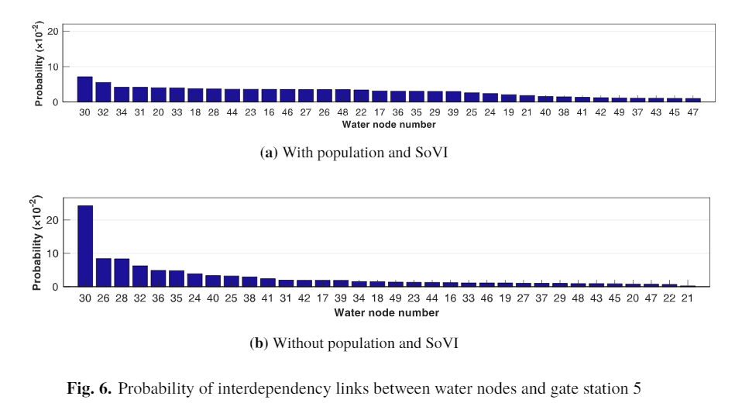

With regard to Fig.8, we present two examples instead of just one to explicitly show that due to the probabilistic estimation of interdependent links, the structure of the interdependent networks can be different, leading to different resilience curves. This figure also shows that dynamic ranking leads to faster recovery, which has been explained in the text.